NOTE: Words in light red font are suggestions only and should be deleted. See other suggestions here: https://lions4-a1.org/creating-a-district-newsletter/
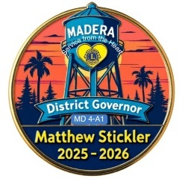

LIONS DISTRICT 4-A1 NEWSLETTER
MONTH YEAR ~ VOLUME XX – Number 6
”WE SERVE” - Northern San Joaquin Valley & Sierra/Nevada Foothills
501(c)(4) Organization - EIN 23-7426310

WEBSITE: lions4-a1.org ~  DISTRICT EMAIL: 4A1LIONS@gmail.com
 FACEBOOK: 4A1LionsClub ~ YOUTUBE: youtube.com/@lions4a1 ~  INSTAGRAM: 4a1Lions
DISTRICT NEWSLETTERS: LINK ~ EDITOR: Lion Gail Cates ~  NEWSLETTERS' EMAIL: newsletter@lions4-a1.org
2025-26 DISTRICT DIRECTORY LINK (Ask Zone Chairs for password & PDF file) ~ HASHTAG #4A1Lions

~ CALENDAR of EVENTS ~
DISTRICT XXXXX ONLINE CALENDAR LINK
MD4 GOOGLE CALENDAR
LIONS INTERNATIONAL CALENDAR
Present-June 30: Round 9 Bags For Benches – Stockton San Joaquin Lions - FLIER
December 2: 4-A1 Cabinet/GAT Meeting – Zoom Link on District's Calendar
December 3-5: Pete Arellano Memorial Girls Basketball Tournament – Escalon Lions
December 3-4: Christmas To Remember – Moke Hill Lions, West Point Lions, Tri-Dam Lions - FLIER
December 4: MD4 Master Class – District/Club Newsletter Training – Lion Gail is hosting - LINK
December 5: Downtown Madera Christmas Light Parade – Madera Evening Lions - FLIER
December 5: Lions International Leo Day
December 6: Free Hot Chocolate at Christmas on Main 3-8pm – Escalon Lions - LINK
December 6: Pancake Breakfast Fundraiser – Sonora Lions - FLIER
December 6: Holiday Bazaar – See article in October's Newsletter - West Point Lions
-------------
XXXXX ETC.

April 18-26: MD4 Environment Service Week – FLIER
April 23-26: District 4-A1 Convention – Black Oak Casino Resort – SAVE-THE-DATE FLIER
June 20: 4-A1 Lions Allstar Football Game – Tracy CA – See article in this newsletter - LINK
June 12-14: MD4 Council of Governors Meeting – 4th Quarter- District 4-L3 in Los Angeles
June 13: MD4 Student Speakers Final Contest @ COG
June 26-28: MD4 Council of Governors Meeting in LA
July 3-7: Lions Int’l Convention - Hong Kong FLIER
September 3-5: USA/Canada Forum – Memphis TN

July 2-6, 2027: Lions Int’l Convention – Washington DC
Sept 16-18, 2027 – USA/Canada Forum – Huntsville AL

~ ONGOING EVENTS ~
(Zoom links can be found on the District Calendar)
District 4-A1 Cabinet/GAT Meetings – 7pm - 1st Tuesdays
District 4-A1 Membership Orientations – ALL LIONS ARE WELCOMED! 6:30pm - every 4th Tuesday on Zoom except November, December, June & July
District 4-A1 Club Officers’ Town Hall Meetings – 6pm - 3rd Monday of the month
District 4-A1 Marketing Meetings – 7:30pm - 4th Mondays
District 4-A1 Rebuild Club Meetings – (Zoom) 4th Friday of the month 6:45pm
District 4-A1 Newsletter Deadline – Flyers, articles & photos due 25th of the month - newsletter@lions4-a1.org

Message from
DISTRICT GOVERNOR xxxxxxxxxx

Holiday Greetings from the District Governor
Dear Lions, Leos, and Friends of District 4-A1,

-----------XXXX

~ Lion Matthew H. Stickler
District Governor, District 4-A1 - Lions International

XXXX SAMPLE HEADING
INSERT FLIERS OR PHOTOS below the heading for interest

PEACE POSTER/ESSAY CONTEST:
Together As One
(INSERT PHOTOS HERE)
2025-2026 District 4-A1 Winner:
Brianna Rodriguez from Avery Middle School
~ Jeff Hammar, Peace Poster/Essay Contest Chair

California Lions Foundation
MENTAL HEALTH, YOUTH & FIRST RESPONDERS GRANTS
https://californialionsfoundation.org/mental-health-grants

RE: California Lions Foundation (CLF) Specialty Grants for the period of October 1 through December 31, 2025… Maximum aggregate grant is $2,000 per Lions District in MD4 – AND maximum grant per Lions Club is $500
For questions or additional information, contact PDG John Schroeder PDGJohnCLF@gmail.com 408-890-7119.
Allow 2-3 weeks for your completed grant application to be processed. Email completed grant application to PDGJohnCLF@gmail.com or hard mail to:
California Lions Foundation, c/o John Schroeder
5970 Waterfront PL, Long Beach CA 90803
DOWNLOAD APPLICATION

AI-POWERED ASSISTANCE FOR LIONS
https://www.lionsclubs.org/en/about-lion-ai
"We’ve brought the power of AI to lionsclubs.org. Our new AI assistant, Ellie, is designed to help Lions and Leos do more and get more out of the resources on our website. So, let’s get to know the technology and how it can help you save time and find the assistance you need."
AI tools developed by Lions
- LionsMap2Grow – Develop a plan to grow your club.
- LionsMarket2Grow – Turn service into great marketing.
- LionsServe2Grow – Organize a service carnival.
- LionsLearn2Grow – Develop training and solve problems.

XXXX ETC.

UPCOMING EVENTS SECTION (in date-order)

MD4 CONVENTION Feb 20-22
https://md4lions.org/convention

"Join us aboard the historic Queen Mary in Long Beach, California, for the 107th California Lions MD-4 Convention, happening February 20–22. Lions from across the state will come together for three days of fellowship, leadership development, inspiring speakers, and celebrations of service. Don’t miss this unforgettable opportunity to connect with fellow Lions while experiencing one of California’s most iconic landmarks."

XXXXX ETC.

ALPHA & OMEGA
LEO NEWS SECTION
https://www.lionsclubs.org/en/discover-our-clubs/about-leos


DISTRICT LEO CHAIRPERSON – XXXXXXXXXX

List of Leos, Instagram or other Social Media Links, Sponsoring Lions Club

INTERNATIONAL LEO DAY – Dec 5
"Join Leos from around the world as we celebrate the 68th anniversary of the Leo Club Program. Watch the winning 2025 Leo Video Contest entries (#HeartofaLeo) and hear about new opportunities for Leos." - REGISTER

XXXXXX HIGH SCHOOL LEO CLUB
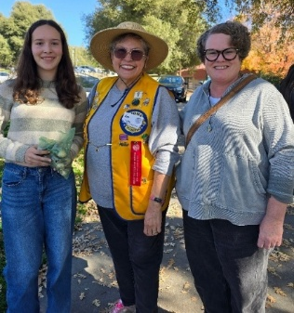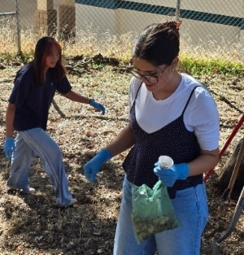

XXXXXX HIGH SCHOOL LEO CLUB

XXXXXX HIGH SCHOOL LEO CLUB

CLUB NEWS SECTION

Check out the clubs’ fundraisers & events in the Calendar on page 1 of each NEWSLETTER and on our district’s Calendar, Facebook, & Instagram.
CLUBS – Please send a quick notification to Newsletter Editor XXXXX each time you have social media posts to include in upcoming District’s Newsletters!

XXXXX LIONS
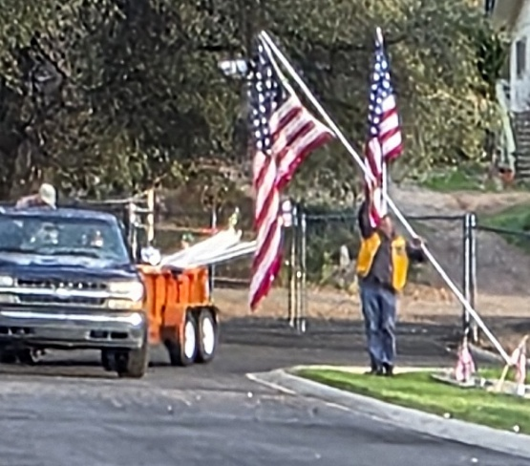
We have had so much fun this month! We participated in the Coarsegold Rodeo Trunk or Treat with our Lions "Welcome to the Jungle"-themed car and passed out 12 huge bags of candy. We also helped VFW place and take down flags at Oakhurst Cemetery for Veterans Day.
~ Lion XXXXXX - FACEBOOK PAGE

XXXXX LIONS

XXXXX LIONS

XXXXX LIONS

DIRECTORY
To contact these Lions, ask your Zone Chair for the District Directory (PDF or hardcopy)

2025-2026 DISTRICT XXXXX

DISTRICT GOVERNOR
Matthew Stickler

IMMEDIATE PAST DISTRICT GOVERNOR
Eric Cheung

1ST VICE DISTRICT GOVERNOR
Steve Moore

2ND VICE DISTRICT GOVERNOR
Rob Hyatt

CABINET SECRETARY
Maggie Stickler

CABINET TREASURER
Patricia Casey-Gillum

GLOBAL ACTION TEAM (GAT)
Matthew Stickler – District Chair

Global Leadership Team Coordinator (GLT) Claudia Miller

Global Membership Team Coordinator (GMT) Rob Hyatt

Global Extension Team Coordinator (GET) Samantha Pierce

Global Service Team Coordinator (GST) Beth Estante

District GMT Family & Women’s Specialist – Maggie Stickler

XXXXX REGION

XXXXX Zone 1 Chair – Pedro “Rick” Hernandez Jr
CERES (2250)
CROWS LANDING (2253)
GUSTINE (2259)
HUGHSON (135129)
LOS BANOS (2270)
MODESTO 500 (2279)
PATTERSON (2286)

XXXX ETC.

LIONS INTERNATIONAL, MD4 & 4-A1 ENDORSED SERVICE PROJECTS

LIONS INTERNATIONAL – MD4 CALIFORNIA & DISTRICT 4-A1 CARE SERVICE PROJECTS
Beth Estante, GST

LIONS IN SIGHT OF CALIFORNIA & NEVADA
Paul Wagner

LIONS PROJECT for CANINE COMPANIONS
PDG Don Allen

XXXX ETC.

4-A1 & MD4 ENDORSED FOUNDATIONS

CALIFORNIA LIONS FOUNDATION
Todd Riebe

EAR OF THE LION FOUNDATION
Terry Brooks, Treasurer
https://earofthelion.org/
800-327-8077
Email: hearfoundation@aol.com

FOURTH DISTRICT STUDENT SPEAKERS FOUNDATION
PDG Chris Ohrmund, President
ohrmu@aol.com
https://studentspeakersfoundation.org/
PCC Claudia Miller, District Trustee

LIONS CLUBS INTERNATIONAL FOUNDATION
PDG Kent Christensen, 4-A1 LCIF Chair
PDG Don Allen, 4-A1 LCIF Co-Chair

XXXX ETC.

STANDING COMMITTEES

BUDGET COMMITTEE
XXXX

CONVENTION MANAGEMENT
XXXX ETC.

OPERATIONS COMMITTEES

CONSTITUTION AND BY-LAWS
Chair - Claudia Miller
Matt Stickler, District Governor
Steve Moore, 1st VDG
Rob Hyatt, 2nd VDG

XXXX ETC.

CONTESTS & AWARDS

BULLETIN & NEWSLETTER CONTEST
Maggie Stickler, Cabinet Secretary

EDITOR'S NOTE: Any changes, additions, or corrections, please let Lion XXXXX know!

